1. Find all books whose author is Faisal Abid and display name of book authors and

Categories

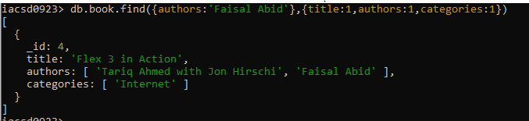

2. List all the books with category Internet at first position in category array

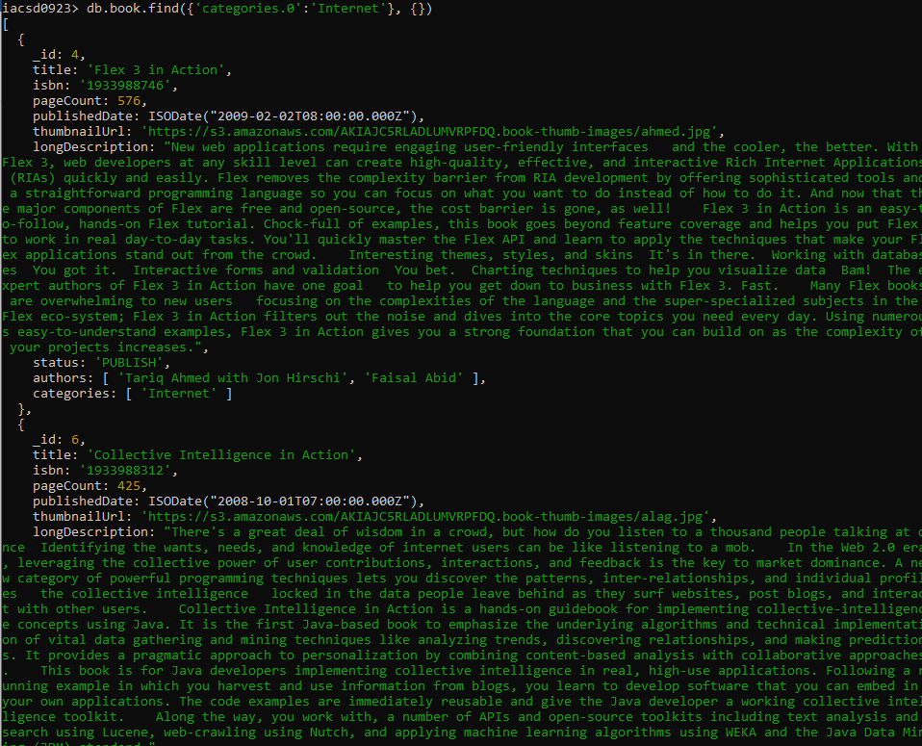

3. Change the status of books “undergoing change” for books having more than 500

pages and published in 2009

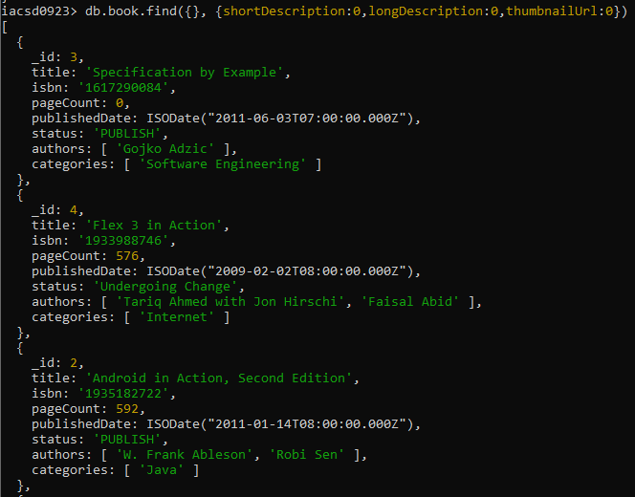

4. Find all the books containing word highlighting and depth in long description of the

Book

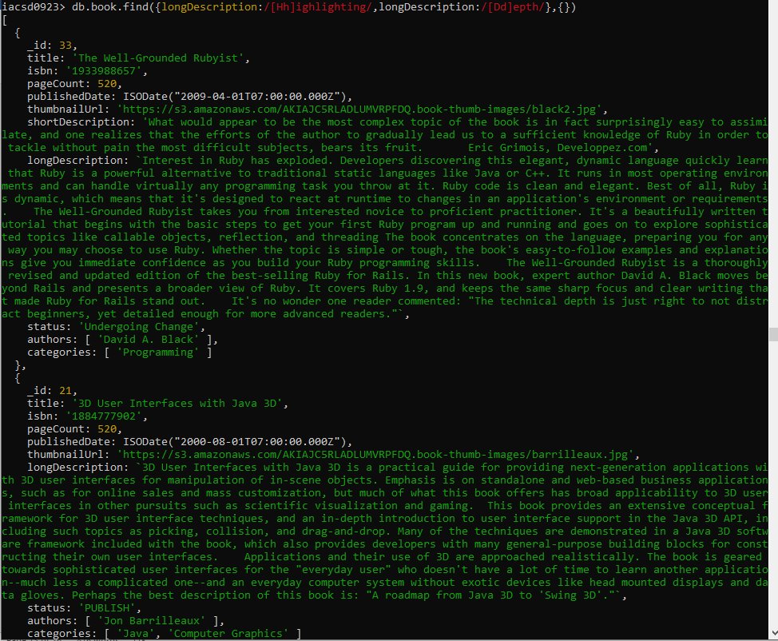

5. Display all books published in 2009

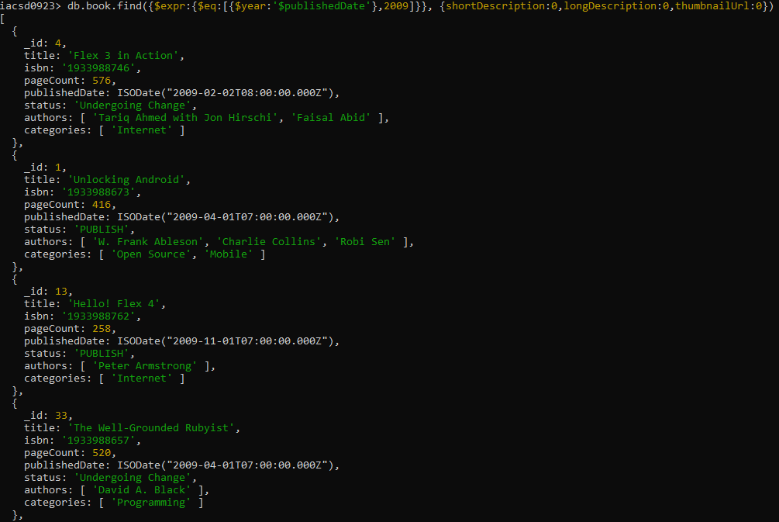

6. Find all books with pageCount is either 500 or 556 or 670

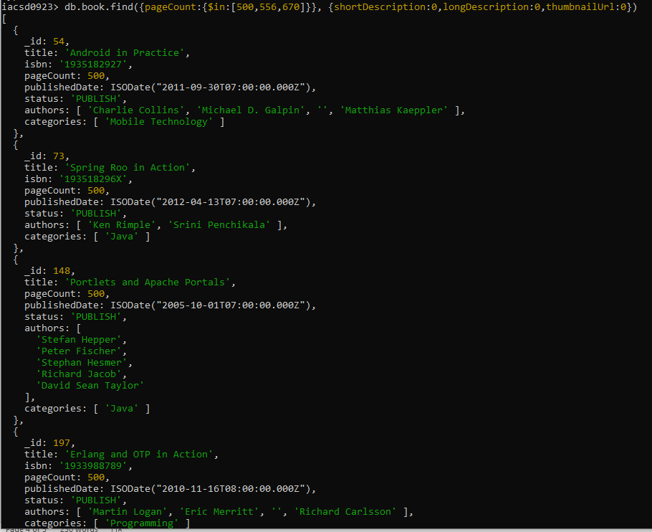

7. Add 2 categories “kindle” and “hard bind” in all the books if its pageCount >200 and

< 500 or number of pages >500

8. List all the books which has thumbnailUrl key

9. Add key type with values [“fiction”,”moral stories”,”adventurous”] in all books

whose title starts with Fl and contains a some where in the name

10. Add a key comments :[{comment:” like the book” ,date:ISODate(“2019-09-01”)},

11. Add new author “myauthor” at position 2 for all books whose title starts with h or m

and contains s at 2nd last position

12. Increase pageCount by 100 for all books whose author at 1 st position is “Gal

Shachor”

13. Overwrite “Magnus Rydin" with name “Fr”

14. List all books title, status, pageCount, comments for all books with pages > 300 or <

500 or title starts with a or isbn starts with 193